WEEK-1: HTML Frames: Frame Structure: Design a webpage for the online book store using HTML frames. Include a navigation frame, a content frame for displaying book details, and a footer frame for additional information.
WEEK1.html:
<!DOCTYPE html>
<html>
<head>
<title>Online Book Store</title>
</head>
<frameset rows="20%,70%,10%" border="2">
<iframe src=""></iframe>
<frame src="navigation.html" name="navFrame">
<frame src="content.html" name="contentFrame">
<frame src="footer.html" name="footerFrame">
</frameset>
</html>
Navigation.html:
<!DOCTYPE html>
<html>
<head>
<title>Navigation</title>
</head>
<body bgcolor="BBBBBB">
<h3>Book Categories</h3>
<h1>Hello World Welcome to VNRVJIET</h1>
<ul>
<li><a href="https://www.microsoft.com" target="contentFrame">Computer Science</a></li>
<li><a href="https://www.ieee.org target="contentFrame">Electronics</a></li>
<li><a href="content.html" target="contentFrame">Mechanical</a></li>
<li><a href="content.html" target="contentFrame">Civil</a></li>
</ul>
</body>
</html>

Footer.html:
<!DOCTYPE html>
<head>
<title>Footer</title>
</head>
<body bgcolor="90EE90" align="center">
<p>2025 Online Book Store | Contact: Support@bookstore.com</p>
</body>
</html>

Content.html:
<!DOCTYPE html>
<html lang="en">
<head>
<meta charset="UTF-8">
<title>Book Store</title>
<link rel="stylesheet" href="content.css">
</head>
<body>

<section class="categories">
<h2>Book Categories</h2>
<ul>
<li>Fiction</li>
<li>Non-Fiction</li>
<li>Science</li>
<li>Technology</li>
<li>Children</li>
</ul>
</section>

<section class="books">
<h2>Available Books</h2>
<table>
<tr>
<th>Book Name</th>
<th>Author</th>
<th>Price</th>
<th>Buy</th>
</tr>
<tr>
<td>The Alchemist</td>
<td>Paulo Coelho</td>
<td>$12</td>
<td><button>Buy</button></td>
</tr>
<tr>
<td>Atomic Habits</td>
<td>James Clear</td>
<td>$15</td>
<td><button>Buy</button></td>
</tr>
<tr>
<td>Clean Code</td>
<td>Robert C. Martin</td>
<td>$20</td>
<td><button>Buy</button></td>
</tr>
</table>
</section>

<section class="order">
<h2>Order a Book</h2>
<form>
<label>Full Name</label>
<input type="text" required>

<label>Email</label>
<input type="email" required>

<label>Select Book</label>
<select>
<option>The Alchemist</option>
<option>Atomic Habits</option>
<option>Clean Code</option>
</select>

<label>Quantity</label>
<input type="number" min="1" value="1">

<button type="submit">Place Order</button>
</form>
</section>

</body>
</html>

WEBPAGE:
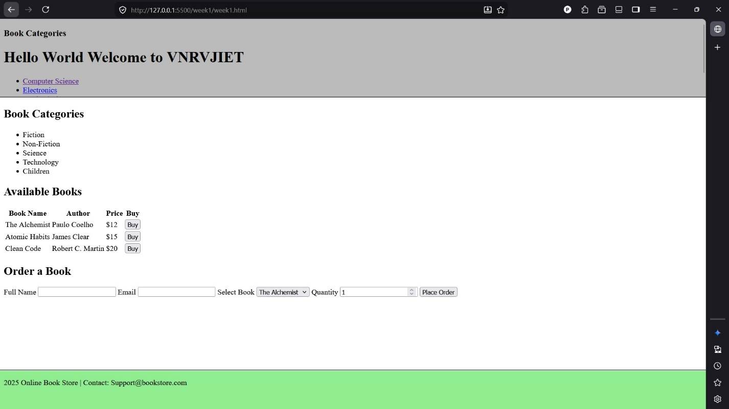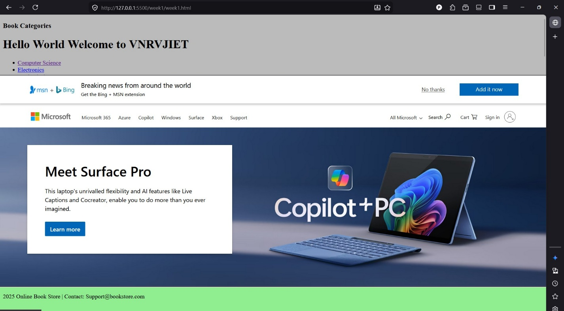

WEEK-2: CSS Styling: Apply CSS styling to enhance the visual appeal of the frames and content. Use appropriate styles for fonts, colors, and layout.
Week2.html:
<!DOCTYPE html>
<html>
<head>
<title>Online Book Store</title>
</head>
<frameset rows="20%,70%,10%" border="2">
<iframe src=""></iframe>
<frame src="navigation.html" name="navFrame">
<frame src="content.html" name="contentFrame">
<frame src="footer.html" name="footerFrame">
</frameset>
</html>
Navigation.html:
<!DOCTYPE html>
<html>
<head>
<title>Navigation</title>
</head>
<body bgcolor="BBBBBB">
<h3>Book Categories</h3>
<h1>Hello World Welcome to VNRVJIET</h1>
<ul>
<li><a href="https://www.google.com" target="contentFrame">Computer Science</a></li>
<li><a href="content.html" target="contentFrame">Electronics</a></li>
<li><a href="content.html" target="contentFrame">Mechanical</a></li>
<li><a href="content.html" target="contentFrame">Civil</a></li>
</ul>
</body>
</html>

Navigation.css:
body {
font-family: Arial, sans-serif;
background-color: #eeeeee;
padding: 10px;
}

h3 {
color: #2c3e50;
}

ul {
padding-left: 15px;
}

li {
margin: 6px 0;
}

a {
text-decoration: none;
color: #2980b9;
}

a:hover {
text-decoration: underline;
}
Footer.html:
<!DOCTYPE html>
<head>
<title>Footer</title>
</head>
<body bgcolor="90EE90" align="center">
<p>2025 Online Book Store | Contact: Support@bookstore.com</p>
</body>
</html>
Footer.css:
body {
font-family: Arial, sans-serif;
background-color: #90EE90;
margin: 0;
text-align: center;
}

p {
font-size: 14px;
padding-top: 10px;
}
Content.html:
<!DOCTYPE html>
<html lang="en">
<head>
<meta charset="UTF-8">
<title>Book Store</title>
<link rel="stylesheet" href="content.css">
</head>
<body>

<!-- Categories List -->
<section class="categories">
<h2>Book Categories</h2>
<ul>
<li>Fiction</li>
<li>Non-Fiction</li>
<li>Science</li>
<li>Technology</li>
<li>Children</li>
</ul>
</section>

<!-- Books Table -->
<section class="books">
<h2>Available Books</h2>
<table>
<tr>
<th>Book Name</th>
<th>Author</th>
<th>Price</th>
<th>Buy</th>
</tr>
<tr>
<td>The Alchemist</td>
<td>Paulo Coelho</td>
<td>$12</td>
<td><button>Buy</button></td>
</tr>
<tr>
<td>Atomic Habits</td>
<td>James Clear</td>
<td>$15</td>
<td><button>Buy</button></td>
</tr>
<tr>
<td>Clean Code</td>
<td>Robert C. Martin</td>
<td>$20</td>
<td><button>Buy</button></td>
</tr>
</table>
</section>

<!-- Order Form -->
<section class="order">
<h2>Order a Book</h2>
<form>
<label>Full Name</label>
<input type="text" required>

<label>Email</label>
<input type="email" required>

<label>Select Book</label>
<select>
<option>The Alchemist</option>
<option>Atomic Habits</option>
<option>Clean Code</option>
</select>

<label>Quantity</label>
<input type="number" min="1" value="1">

<button type="submit">Place Order</button>
</form>
</section>

</body>
</html>
Content.css:
/* General page styling */
body {
font-family: Arial, sans-serif;
background-color: #f5f7fa;
margin: 0;
padding: 15px;
color: #333;
}

/* Section styling */
section {
background: #ffffff;
padding: 15px;
margin-bottom: 20px;
border-radius: 6px;
box-shadow: 0 2px 6px rgba(0,0,0,0.1);
}

/* Headings */
h2 {
color: #2c3e50;
margin-bottom: 10px;
border-bottom: 2px solid #3498db;
padding-bottom: 5px;
}

/* Categories list */
.categories ul {
list-style-type: square;
padding-left: 20px;
}

.categories li {
margin: 5px 0;
}
/* Table styling */
table {
width: 100%;
border-collapse: collapse;
}

th {
background-color: #3498db;
color: white;
padding: 8px;
}

td {
padding: 8px;
border-bottom: 1px solid #ddd;
}

/* Buttons */
button {
background-color: #2ecc71;
color: white;
border: none;
padding: 6px 12px;
border-radius: 4px;
cursor: pointer;
}

button:hover {
background-color: #27ae60;
}

/* Form styling */
form {
display: grid;
row-gap: 8px;
}

input, select {
padding: 6px;
border: 1px solid #ccc;
border-radius: 4px;
}
WEBPAGE:
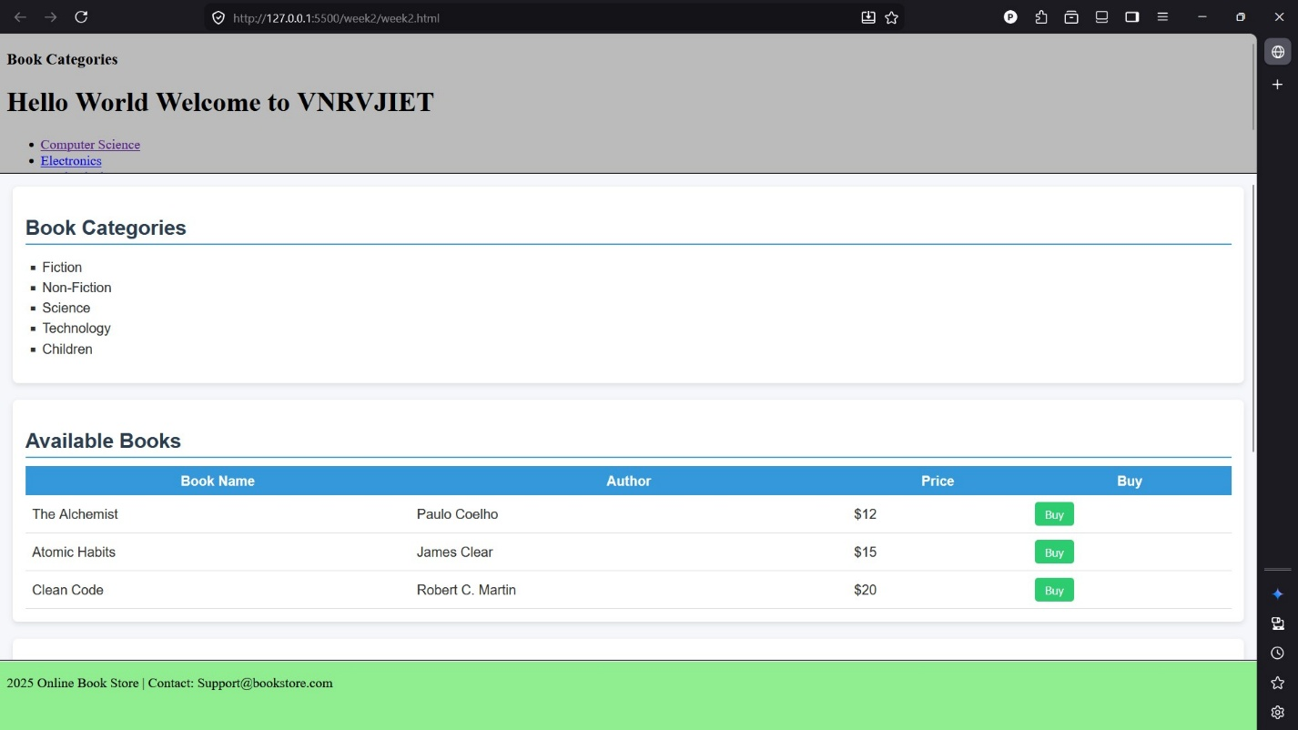
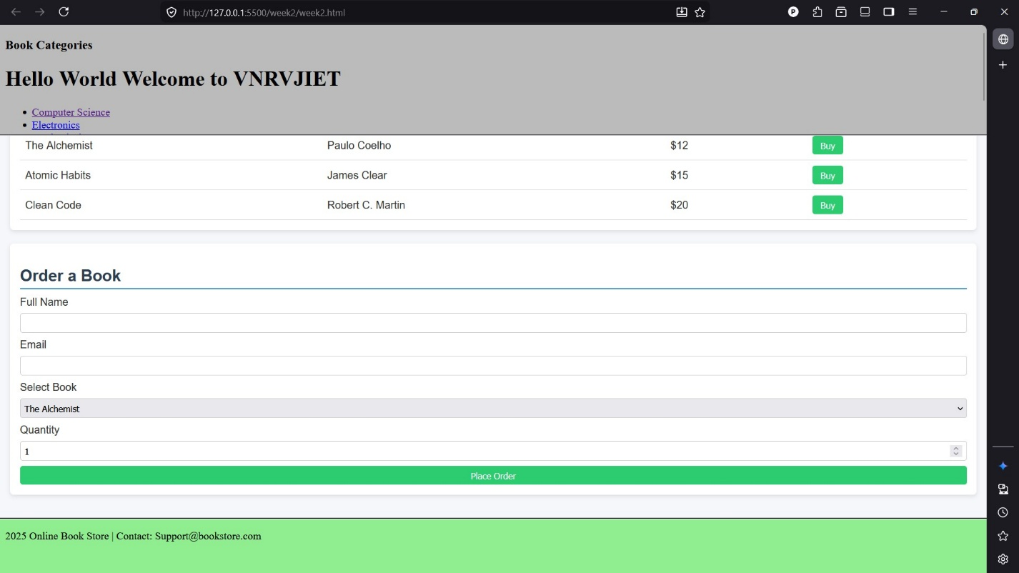

WEEK-3:
JavaScript:
a) User Registration Form
Create a registration form for users signing up on the online bookstore. Validate
the following:
• Username: Should not be empty and must be at least 5 characters long.
• Password: Should not be empty and must be at least 8 characters long.
• Confirm Password: Should match the entered password.
b) Forgot Password Form
Implement a form for users to reset their password. Validate the following:
• Email Address: Should be a valid email format.
• Provide feedback if the email address is not associated with any account.
c) Dynamically Content Loading
Use JavaScript to dynamically load book details into the content frame when a user
clicks on a book in the navigation frame.

Week3.html:
<!DOCTYPE html>
<html>
<head>
<title>Online Book Store - Week 3</title>
</head>
<frameset rows="20%,70%,10%" border="2">
<frame src="navigation.html" name="navFrame">
<frame src="content.html" name="contentFrame">
<frame src="footer.html" name="footerFrame">
</frameset>
</html>
Week3.js:
// week3.js - Dynamically load book details into the content frame

document.addEventListener('DOMContentLoaded', function () {
// This script runs inside the navigation frame (navigation.html)
var navLinks = document.querySelectorAll('a[data-book-id]');
if (!navLinks.length) {
return;
}

var bookData = {
'clean-code': {
title: 'Clean Code',
author: 'Robert C. Martin',
category: 'Technology / Programming',
price: '$20',
isbn: '978-0132350884',
availability: 'In Stock',
description: 'A handbook of agile software craftsmanship focusing on writing clean, maintainable code.'
},
'alchemist': {
title: 'The Alchemist',
author: 'Paulo Coelho',
category: 'Fiction',
price: '$12',
isbn: '978-0061122415',
availability: 'In Stock',
description: 'A novel about a shepherd boy on a journey to realize his personal legend.'
},
'atomic-habits': {
title: 'Atomic Habits',
author: 'James Clear',
category: 'Self Help',
price: '$15',
isbn: '978-0735211292',
availability: 'Limited Stock',
description: 'Practical strategies for building good habits and breaking bad ones.'
},
'ds-algo': {
title: 'Data Structures and Algorithms',
author: 'Narasimha Karumanchi',
category: 'Computer Science',
price: '$25',
isbn: '978-8193245279',
availability: 'Out of Stock',
description: 'Detailed explanations of core data structures and algorithms with interview focus.'
}
};

function loadBookIntoContentFrame(bookId) {
var info = bookData[bookId];
if (!info) {
return;
}

var contentFrame = parent.frames['contentFrame'];
if (!contentFrame || !contentFrame.document) {
return;
}

var doc = contentFrame.document;
var container = doc.getElementById('bookDetails');
if (!container) {
return;
}

container.innerHTML =
'<h3>' + info.title + '</h3>' +
'<p><strong>Author:</strong> ' + info.author + '</p>' +
'<p><strong>Category:</strong> ' + info.category + '</p>' +
'<p><strong>ISBN:</strong> ' + info.isbn + '</p>' +
'<p><strong>Price:</strong> ' + info.price + '</p>' +
'<p><strong>Availability:</strong> ' + info.availability + '</p>' +
'<p><strong>Description:</strong> ' + info.description + '</p>';
}

navLinks.forEach(function (link) {
link.addEventListener('click', function (e) {
e.preventDefault();
var bookId = this.getAttribute('data-book-id');
loadBookIntoContentFrame(bookId);
});
});
});
Registration.html:
<!DOCTYPE html>
<html lang="en">
<head>
<meta charset="UTF-8">
<meta name="viewport" content="width=device-width, initial-scale=1.0">
<title>User Registration - Online Bookstore</title>
<link rel="stylesheet" href="registration.css">
</head>
<body>
<div class="container">
<h2>User Registration</h2>
<form id="registrationForm" autocomplete="off">
<label for="username">Username:</label>
<input type="text" id="username" name="username" required>

<label for="password">Password:</label>
<input type="password" id="password" name="password" required>

<label for="confirmPassword">Confirm Password:</label>
<input type="password" id="confirmPassword" name="confirmPassword" required>

<div id="errorMsg" class="error" style="display:none;"></div>
<button type="submit">Register</button>
<div style="text-align:center; margin-top:15px;">
<a href="forgotpassword.html">Forgot Password?</a>
</div>
</form>
</div>
<script src="registration.js"></script>
</body>
</html>
ForgotPassword.html:
<!DOCTYPE html>
<html lang="en">
<head>
<meta charset="UTF-8">
<meta name="viewport" content="width=device-width, initial-scale=1.0">
<title>Forgot Password - Online Bookstore</title>
<link rel="stylesheet" href="forgotpassword.css">
</head>
<body>
<div class="container">
<h2>Forgot Password</h2>
<form id="forgotPasswordForm" autocomplete="off">
<label for="email">Email Address:</label>
<input type="email" id="email" name="email" required>
<div id="fpErrorMsg" class="error" style="display:none;"></div>
<button type="submit">Reset Password</button>
</form>
</div>
<script src="forgotpassword.js"></script>
</body>
</html>
Forgotpassword.js:

document.addEventListener('DOMContentLoaded', function() {
var form = document.getElementById('forgotPasswordForm');
if (!form) return;
form.addEventListener('submit', function(e) {
e.preventDefault();
var email = document.getElementById('email').value.trim();
var errorMsg = document.getElementById('fpErrorMsg');
errorMsg.style.display = 'none';
errorMsg.innerText = '';

var emailRegex = /^[\w-\.]+@([\w-]+\.)+[\w-]{2,4}$/;
if (!emailRegex.test(email)) {
errorMsg.innerText = 'Please enter a valid email address.';
errorMsg.style.display = 'block';
return;
}

// Simulated check for email association (for demo, only these emails are valid)
var validEmails = ['user1@example.com', 'user2@example.com', 'test@bookstore.com','pranav.tungani@gmail.com'];
if (!validEmails.includes(email)) {
errorMsg.innerText = 'This email address is not associated with any account.';
errorMsg.style.display = 'block';
return;
}

alert('A password reset link has been sent to your email.');
form.reset();
});
});
Registration.js:
// registration.js - Security and validation for registration form

document.addEventListener('DOMContentLoaded', function() {
var form = document.getElementById('registrationForm');
if (!form) return;
form.addEventListener('submit', function(e) {
e.preventDefault();
var username = document.getElementById('username').value.trim();
var password = document.getElementById('password').value;
var confirmPassword = document.getElementById('confirmPassword').value;
var errorMsg = document.getElementById('errorMsg');
errorMsg.style.display = 'none';
errorMsg.innerText = '';

// Username validation
if (username.length < 5) {
errorMsg.innerText = 'Username must be at least 5 characters long.';
errorMsg.style.display = 'block';
return;
}
// Password validation
if (password.length < 8) {
errorMsg.innerText = 'Password must be at least 8 characters long.';
errorMsg.style.display = 'block';
return;
}
// Password strength (at least 1 uppercase, 1 lowercase, 1 number)
var strongRegex = /^(?=.*[a-z])(?=.*[A-Z])(?=.*\d).+$/;
if (!strongRegex.test(password)) {
errorMsg.innerText = 'Password must contain uppercase, lowercase, and a number.';
errorMsg.style.display = 'block';
return;
}
// Confirm password
if (password !== confirmPassword) {
errorMsg.innerText = 'Passwords do not match.';
errorMsg.style.display = 'block';
return;
}
// All validations passed
alert('Registration successful!');
form.reset();

// Navigate to the content page after successful registration
window.location.href = 'navigation.html';
});
});
Webpage:
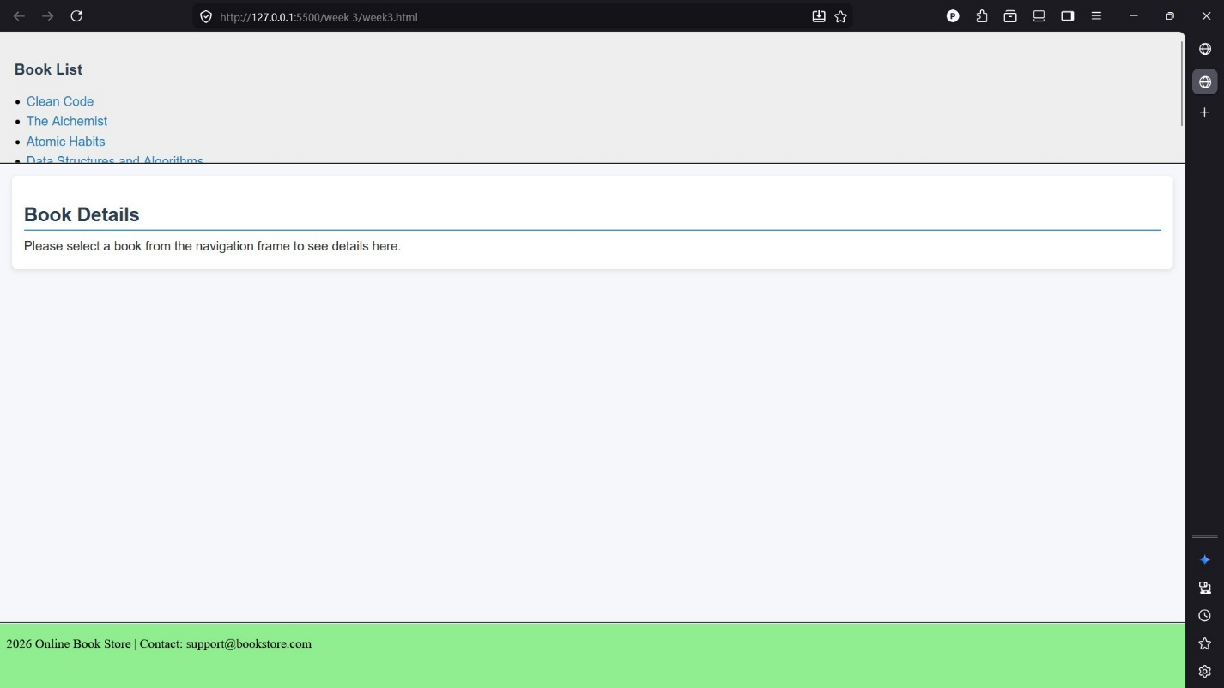

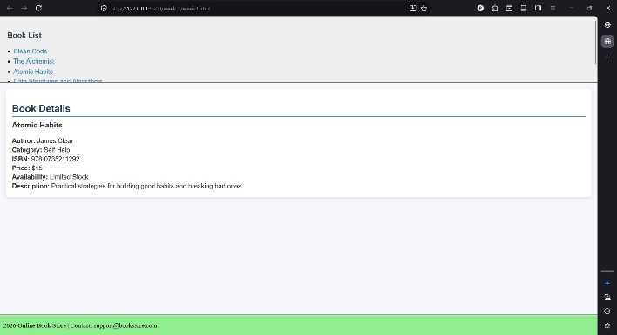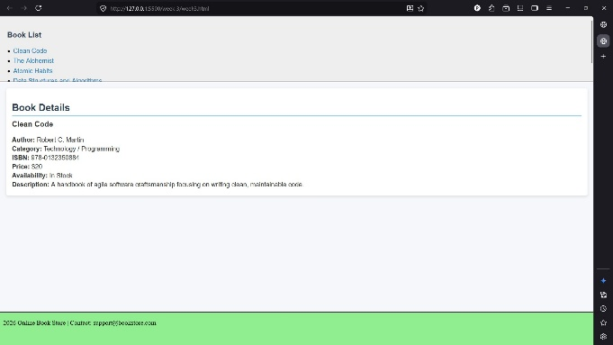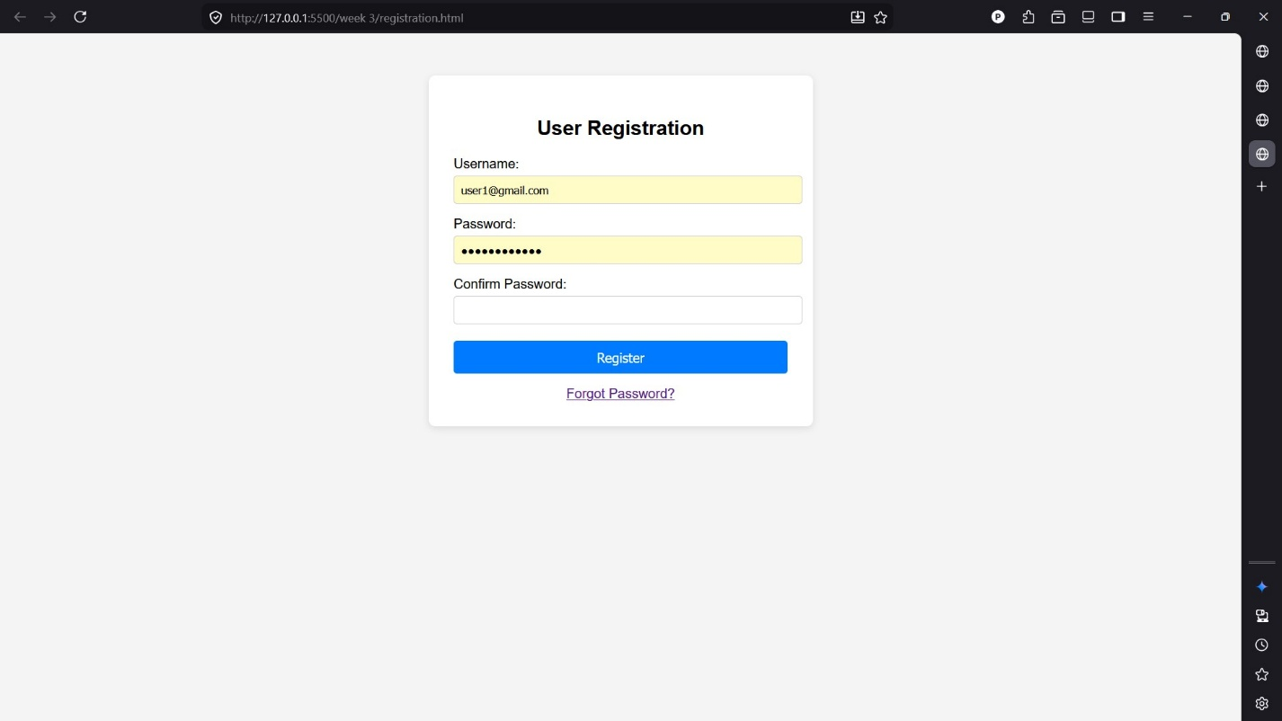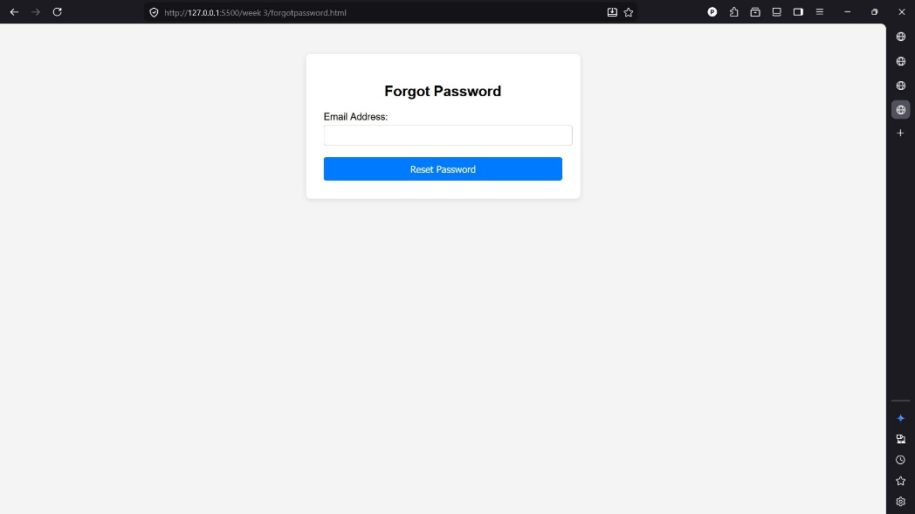

WEEK-4: Shopping Cart Functionality: Implement a simple shopping cart using JavaScript. Allow users to add books to their cart and view the cart's contents.

Cart.html:
<!DOCTYPE html>
<html lang="en">
<head>
<meta charset="UTF-8">
<title>My Cart</title>
<link rel="stylesheet" href="styles.css">
</head>
<body>
<main>
<h1>My Cart</h1>
<a href="index.html">Back to Store</a>

<div id="cart-items"></div>
<p><strong>Total: Rs. <span id="total">0</span></strong></p>
<button onclick="clearCart()">Clear Cart</button>
</main>

<script src="script.js"></script>
</body>
</html>
Index.html:
<!DOCTYPE html>
<html lang="en">
<head>
<meta charset="UTF-8">
<title>Book Store</title>
<link rel="stylesheet" href="styles.css">
</head>
<body>
<main>
<h1>Book Store</h1>
<a href="cart.html">View Cart (<span id="cart-count">0</span>)</a>

<div id="books">
<div class="book">
<h3>The Alchemist</h3>
<p>By Paulo Coelho</p>
<p>Price: Rs. 299</p>
<button onclick="addToCart('The Alchemist', 299)">Add to Cart</button>
</div>

<div class="book">
<h3>Atomic Habits</h3>

<p>By James Clear</p>
<p>Price: Rs. 499</p>
<button onclick="addToCart('Atomic Habits', 499)">Add to Cart</button>
</div>

<div class="book">
<h3>Rich Dad Poor Dad</h3>
<p>By Robert Kiyosaki</p>
<p>Price: Rs. 349</p>
<button onclick="addToCart('Rich Dad Poor Dad', 349)">Add to Cart</button>
</div>

<div class="book">
<h3>Deep Work</h3>
<p>By Cal Newport</p>
<p>Price: Rs. 399</p>
<button onclick="addToCart('Deep Work', 399)">Add to Cart</button>
</div>
</div>
</main>

<script src="script.js"></script>
</body>
</html>
Script.js:
// Get cart from localStorage (or empty array)
function getCart() {
return JSON.parse(localStorage.getItem('cart')) || [];
}

// Save cart to localStorage
function saveCart(cart) {
localStorage.setItem('cart', JSON.stringify(cart));
}

// Add a book to the cart
function addToCart(title, price) {
var cart = getCart();
cart.push({ title: title, price: price });
saveCart(cart);
alert(title + ' added to cart!');
updateCount();
}

// Update the cart count shown on the store page
function updateCount() {
var countEl = document.getElementById('cart-count');
if (countEl) {
countEl.textContent = getCart().length;
}
}

// Show cart items on cart.html
function showCart() {
var cart = getCart();
var container = document.getElementById('cart-items');
if (!container) return;

if (cart.length === 0) {
container.innerHTML = '<p>Your cart is empty.</p>';
document.getElementById('total').textContent = 0;
return;
}

var html = '<ul>';
var total = 0;
for (var i = 0; i < cart.length; i++) {
html += '<li>' + cart[i].title + ' - Rs. ' + cart[i].price + '</li>';
total += cart[i].price;
}
html += '</ul>';
container.innerHTML = html;
document.getElementById('total').textContent = total;
}

// Clear all items from cart
function clearCart() {
localStorage.removeItem('cart');
showCart();
}

// Run on page load
updateCount();
showCart();
Styles.css:
body {
font-family: Arial, sans-serif;
margin: 0;
padding: 0;
background: #f5f7fb;
}
/* Books grid */
#books{
display: flex;
flex-wrap: wrap;
gap: 18px;
justify-content: center;
}

.book {
background: #ffffff;
border-radius: 10px;
box-shadow: 0 2px 8px rgba(11,37,69,0.06);
padding: 16px;
width: 240px;
display: flex;
flex-direction: column;
gap: 8px;
transition: transform 160ms ease, box-shadow 160ms ease;
}

.book:hover {
transform: translateY(-6px);
box-shadow: 0 10px 22px rgba(11,37,69,0.10);
}

.book h3 { margin: 0; font-size: 1.05rem; color: #071b2d; }
.book p { margin: 0; color: #475569; font-size: 0.9rem; }
.book .price { font-weight: 700; color: #111827; }

button {
padding: 10px 14px;
background-color: #0b74de;
color: white;
border: none;
border-radius: 8px;
cursor: pointer;
align-self: start;
transition: background-color 120ms ease, transform 120ms ease;
}

button:hover { background-color: #075fae; transform: translateY(-2px); }
button:active { transform: translateY(0); }

/* Cart link badge */
#cart-count {
background: #ef4444;
color: #fff;
padding: 2px 8px;
border-radius: 999px;
margin-left: 6px;
font-weight: 700;
font-size: 0.85rem;
}

/* Cart page styles */
#cart-items { margin: 18px 0; }
.cart-item {
display: flex;
justify-content: space-between;
align-items: center;
padding: 10px 12px;
background: #fff;
border-radius: 8px;
box-shadow: 0 1px 4px rgba(11,37,69,0.04);
margin-bottom: 10px;
}

.cart-item .name { font-weight: 600; }
.cart-item .price { color: #0b2545; font-weight: 700; }

/* Responsive */
@media (max-width: 600px) {
main { margin: 18px; padding: 12px; }
.book { width: 100%; max-width: 420px; }
}

/* Small utility */
.muted { color: #6b7280; font-size: 0.9rem; }

/* Style cart list rendered by script.js */
#cart-items ul { list-style: none; padding: 0; margin: 0; }
#cart-items ul li {
padding: 10px 12px;
background: #fff;
border-radius: 8px;
box-shadow: 0 1px 4px rgba(11,37,69,0.04);
margin-bottom: 10px;
display: flex;
justify-content: space-between;
align-items: center;
}
#cart-items ul li::after { content: attr(data-price); font-weight:700; color:#0b2545; }
WEBPAGE:
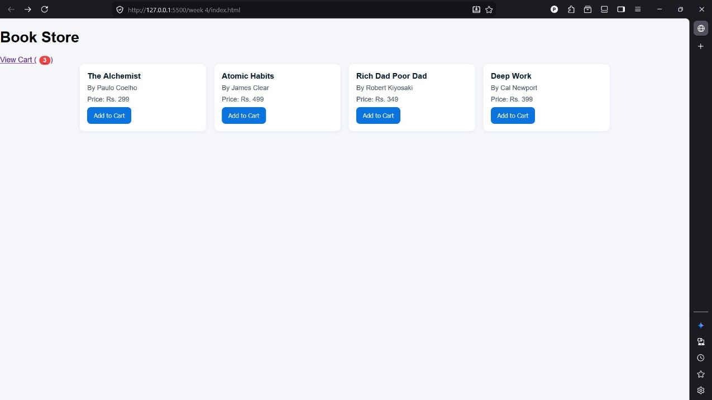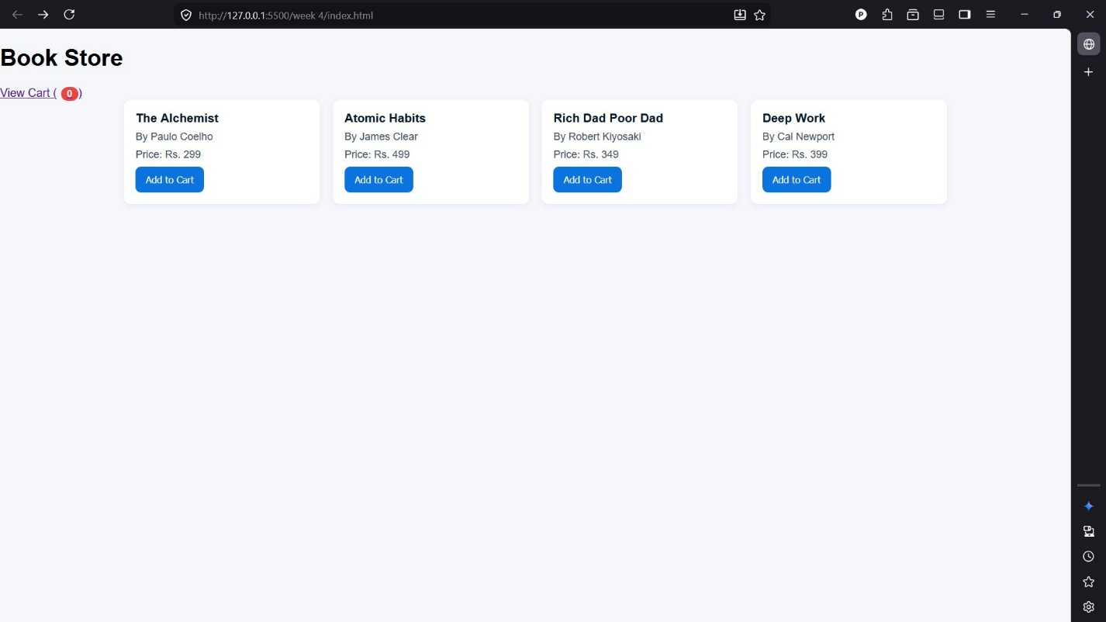
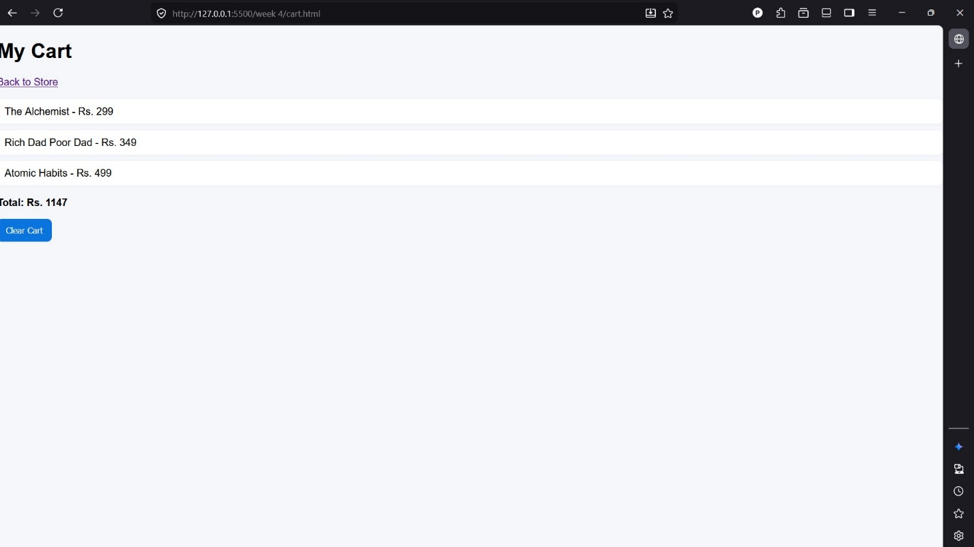

WEEK-5: XML Structure and Design: Book Catalog XML: Design an XML structure to represent the catalog of books in the online store. Include details such as book title, author, genre, price, and availability.

Book_catalog_view.html:
<!doctype html>
<html lang="en">
<head>
<meta charset="utf-8">
<meta name="viewport" content="width=device-width,initial-scale=1">
<title>Book Catalog Viewer</title>
<link rel="stylesheet" href="book_catalog.css">
</head>
<body>
<header class="site-header">
<h1>Book Catalog</h1>
</header>

<main class="container">
<div class="controls">
<input id="search" placeholder="Search by title, author, or genre" />
<select id="genreFilter"><option value="">All genres</option></select>
<button id="refresh">Refresh</button>
</div>

<div id="catalog" class="grid" aria-live="polite"></div>
</main>

<script src="book_catalog.js"></script>
</body>
</html>
Book_catalog.css:
:root{
--bg:#f6f8fa;
--card:#ffffff;
--muted:#6b7280;
--accent:#2563eb;
--success:#10b981;
--danger:#ef4444;
--glass:rgba(255,255,255,0.6);
}
*{box-sizing:border-box}
body{font-family:Segoe UI,Roboto,Arial,sans-serif;margin:0;background:var(--bg);color:#111}
.site-header{background:linear-gradient(90deg,var(--accent),#7c3aed);color:white;padding:20px 24px}
.site-header h1{margin:0;font-size:1.25rem}
.container{max-width:1100px;margin:24px auto;padding:0 16px}
.controls{display:flex;gap:10px;align-items:center;margin-bottom:18px}
.controls input, .controls select{padding:10px 12px;font-size:0.95rem;border:1px solid #e6e9ee;border-radius:8px;min-width:0}
.controls button{padding:10px 14px;border-radius:8px;background:var(--accent);color:white;border:none;cursor:pointer}
.grid{display:grid;grid-template-columns:repeat(auto-fill,minmax(220px,1fr));gap:16px}
.card{background:var(--card);padding:14px;border-radius:12px;box-shadow:0 6px 20px rgba(20,20,40,0.06);display:flex;flex-direction:column;gap:8px}
.title{font-weight:700;font-size:1.02rem}
.author{color:var(--muted);font-size:0.92rem}
.meta{display:flex;justify-content:space-between;align-items:center;margin-top:6px}
.genre{font-size:0.85rem;padding:6px 8px;border-radius:999px;background:var(--glass);color:#374151}
.price{font-weight:700;color:var(--accent)}
.availability{font-size:0.85rem;padding:6px 8px;border-radius:999px}
.availability.in-stock{background:rgba(16,185,129,0.08);color:var(--success);border:1px solid rgba(16,185,129,0.12)}
.availability.out-of-stock{background:rgba(239,68,68,0.08);color:var(--danger);border:1px solid rgba(239,68,68,0.12)}
.empty{padding:30px;text-align:center;color:var(--muted)}
@media (max-width:520px){.controls{flex-direction:column;align-items:stretch}.controls input{width:100%}}
Book_catalog.js:
async function loadCatalog(){
try{
const res = await fetch('book_catalog.xml');
if(!res.ok) throw new Error('Failed to load XML');
const text = await res.text();
const parser = new DOMParser();
const xml = parser.parseFromString(text, 'application/xml');

const books = Array.from(xml.getElementsByTagName('book')).map(b => {
const title = b.getElementsByTagName('title')[0]?.textContent || '';
const author = b.getElementsByTagName('author')[0]?.textContent || '';
const genre = b.getElementsByTagName('genre')[0]?.textContent || '';
const priceEl = b.getElementsByTagName('price')[0];
const price = priceEl?.textContent || '';
const currency = priceEl?.getAttribute('currency') || '';
const availEl = b.getElementsByTagName('availability')[0];
const availabilityCount = availEl?.textContent || '0';
const status = availEl?.getAttribute('status') || (Number(availabilityCount)>0 ? 'in-stock' : 'out-of-stock');
return { id: b.getAttribute('id'), title, author, genre, price, currency, availabilityCount: Number(availabilityCount), status };
});

return books;
}catch(err){
console.error(err);
return null;
}
}

function renderBooks(books){
const container = document.getElementById('catalog');
container.innerHTML = '';
if(!books || books.length===0){
container.innerHTML = '<div class="empty">No books found.</div>';
return;
}

const frag = document.createDocumentFragment();
books.forEach(b=>{
const card = document.createElement('article');
card.className = 'card';
card.innerHTML = `
<div class="title">${escapeHtml(b.title)}</div>
<div class="author">by ${escapeHtml(b.author)}</div>
<div class="meta">
<div class="genre">${escapeHtml(b.genre)}</div>
<div class="price">${escapeHtml(b.currency)} ${escapeHtml(b.price)}</div>
</div>
<div style="display:flex;justify-content:space-between;align-items:center">
<div class="availability ${b.status === 'in-stock' ? 'in-stock' : 'out-of-stock'}">${b.status === 'in-stock' ? 'In stock' : 'Out of stock'}</div>
<div style="color:var(--muted);font-size:0.85rem">Qty: ${b.availabilityCount}</div>
</div>
`;
frag.appendChild(card);
});
container.appendChild(frag);
}

function escapeHtml(s){
return String(s).replaceAll('&','&amp;').replaceAll('<','&lt;').replaceAll('>','&gt;');
}

function applyFilters(allBooks){
const q = document.getElementById('search').value.trim().toLowerCase();
const genre = document.getElementById('genreFilter').value;
let filtered = allBooks.filter(b => {
const hay = `${b.title} ${b.author} ${b.genre}`.toLowerCase();
return hay.includes(q) && (genre === '' || b.genre === genre);
});
renderBooks(filtered);
}

(async function init(){
const allBooks = await loadCatalog();
if(allBooks === null){
document.getElementById('catalog').innerHTML = '<div class="empty">Could not load catalog. Make sure <code>book_catalog.xml</code> is next to the viewer.</div>';
return;
}

// populate genre filter
const genres = Array.from(new Set(allBooks.map(b=>b.genre).filter(Boolean))).sort();
const select = document.getElementById('genreFilter');
genres.forEach(g=>{
const opt = document.createElement('option');
opt.value = g; opt.textContent = g; select.appendChild(opt);
});

// initial render
renderBooks(allBooks);

// wire controls
document.getElementById('search').addEventListener('input', ()=>applyFilters(allBooks));
select.addEventListener('change', ()=>applyFilters(allBooks));
document.getElementById('refresh').addEventListener('click', async ()=>{
const refreshed = await loadCatalog();
if(refreshed) {
allBooks.length = 0; allBooks.push(...refreshed);
applyFilters(allBooks);
}
});
})();

Book_catalog.xml:
<?xml version="1.0" encoding="UTF-8"?>
<catalog>
<book id="B001">
<title>The Great Gatsby</title>
<author>F. Scott Fitzgerald</author>
<genre>Fiction</genre>
<price currency="USD">10.99</price>
<availability status="in-stock">15</availability>
</book>

<book id="B002">
<title>A Brief History of Time</title>
<author>Stephen Hawking</author>
<genre>Science</genre>
<price currency="USD">15.50</price>
<availability status="in-stock">8</availability>
</book>

<book id="B003">
<title>Clean Code</title>
<author>Robert C. Martin</author>
<genre>Technology</genre>
<price currency="USD">32.00</price>
<availability status="in-stock">23</availability>
</book>

<book id="B004">
<title>To Kill a Mockingbird</title>
<author>Harper Lee</author>
<genre>Fiction</genre>
<price currency="USD">12.99</price>
<availability status="out-of-stock">0</availability>
</book>

<book id="B005">
<title>Sapiens: A Brief History of Humankind</title>
<author>Yuval Noah Harari</author>
<genre>History</genre>
<price currency="USD">18.75</price>
<availability status="in-stock">5</availability>
</book>
</catalog>

WEBPAGE:
